Analytical Report of Just Eat Takeaway (JET)

Table of Contents

Executive Summary 2

I. Introduction 2

II. Technical Analysis of Stock Market 3

1. Descriptive Analysis 3

a. Stock prices: 3

b. Stock returns: 5

c. JET returns analysis using empirical rules: 5

d. Jet return analysis using boxplot and histogram: 7

e. Comparing returns using boxplot and histogram: 8

2. Correlation and Regression Analysis 10

a. Correlation: 10

b. Regression analysis: 12

3. Time Series Analysis 16

a. Moving Average 16

b. Forecast: 17

4. Summary: 20

III. Fundamental Analysis: 20

1. Income statements: 20

2. Capital structure: 21

3. Strategic Analysis: 21

IV. Conclusion and Suggestions: 22

V. Reference 22

VI. Appendix 24

Appendix 1: Deliveroo historical data is limited from the 31st of March 2021 24

Appendix 2: Error metrics calculated for each forecasting method 25

# **Executive Summary**

This report analysis the performance of Just Eat Takeaway (JET), a large enterprise in the online delivery market, by conducting technical and fundamental analysis in two separate sections. By doing so, it is expected to provide results that could support the decision of investors who are interested in the company.

JET's stock performance is initially compared to that of one of its industry competitors, OCADO group, a supermarket delivery company, and the FTSE100 market index. After performing descriptive analysis, it is discovered that JET and OCADO stocks are more volatile than the FTSE market. As a result, investing in FTSE index stocks is a safer bet for investors. However, after delving deeper into JET's stock using empirical rules, the stock appears to have a high probability of generating significantly higher returns than the others, despite its high volatility. As a result, JET stock is appropriate for aggressive investors. Additionally, correlation and regression analysis are also applied revealing a strong positive relationship between JET and OCADO stock prices and a weak inverse relationship between JET and FTSE prices. As a result, investors are advised to focus on JET's competitor while forecasting the stocks. Importantly, investors are advised to use Holt's Winters Method (Multiplicative) to forecast, and the first quarter of 2022 is the best time to buy JET stock because it is expected to decline.

Finally, when combined the above analysis with the fundamental analysis of the company annual reports from 2019 to 2021, JET is expected to be a profitable investment and should be invested in the long-term to avoid its short-term instability.

# **Introduction**

Just Eat Takeaway (JET) is a market leader in the UK food delivery sector. By 2021, the brand controlled 45% of the food delivery market (Edison Trends, 2021). With that important information in mind, this research will conduct a data-driven analysis to delve deeper into JET's performance in order to assess its suitability for future investment.

The first section of the research will conduct a technical analysis of JET and its primary competitor on the stock market using historical data collected from the 2nd of March 2020 to the 28th of February 2022. To begin, a descriptive analysis will be performed to evaluate the stock results and volatility of JET, its competitor, and the market index (FTSE). Following that, a correlation and regression analysis of these companies' stock prices will be provided to investigate their impact on one another. Finally, the report will use time series analysis with the implementation of several techniques such as the moving average, single exponential smoothing, holt's winter, and so on to forecast JET future stocks and select the most appropriate technique to aid investors' decisions. Meanwhile, the second part will include a fundamental analysis of JET's financial statements and strategic report from 2019 to 2021. Finally, the outcomes of these two parts will be compiled and contrasted in order to make recommendations to investors.

# **Technical Analysis of Stock Market**

JET direct competitors in the UK’s online food delivery market are Uber Eats and Deliveroo; however, Uber Eats is not listed in London market whilst Deliveroo historical data in the market is only shown from the 31st of March 2021 (Appendix 1). Therefore, an alternative in a similar grocery delivery market is chosen in this report namely OCADO (OCA) listed as OCDO.L in London market.

## Descriptive Analysis

### Stock prices:

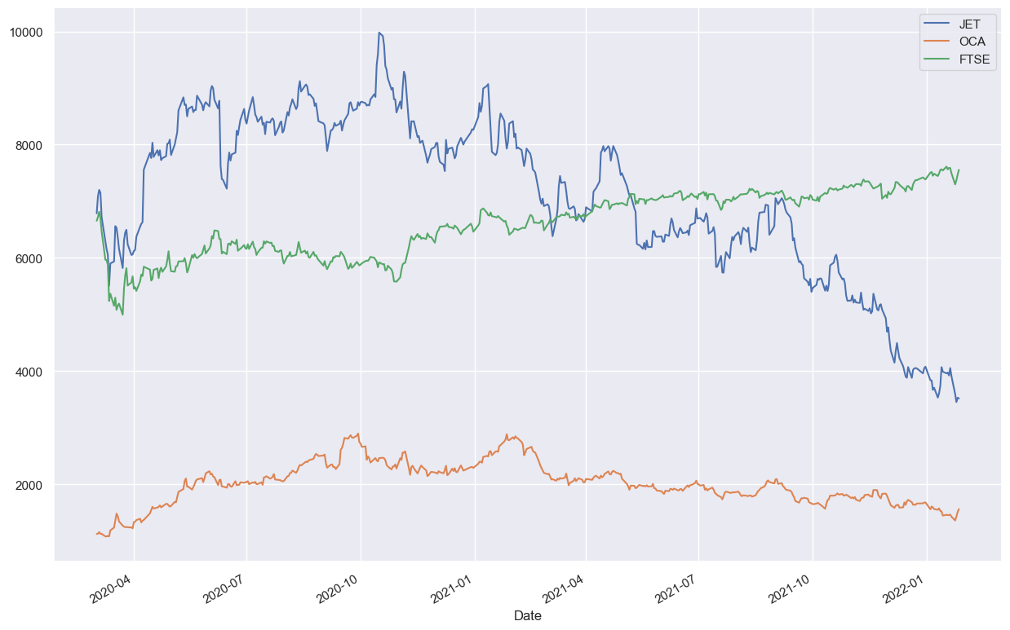

*Figure 1: JET, OCA and FTSE stock prices*

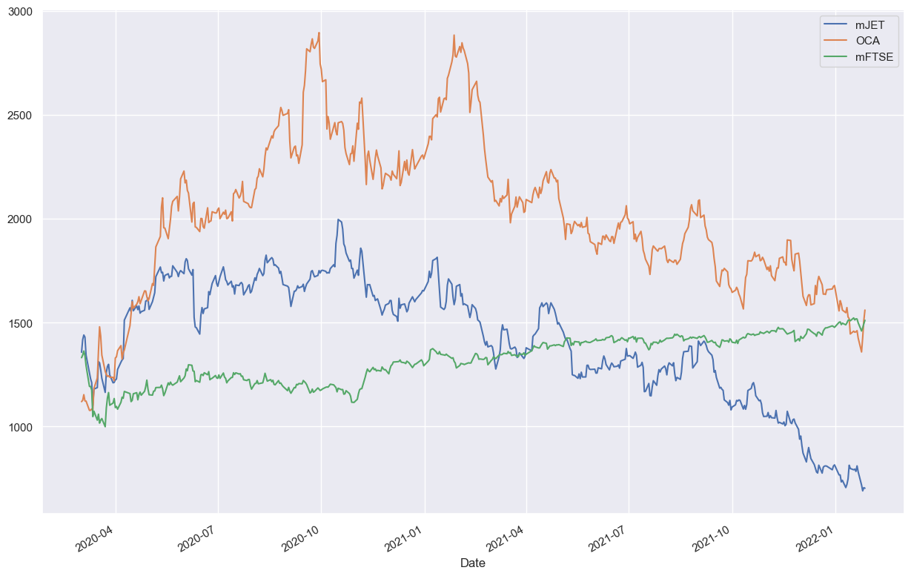

Figure 2: Modified Stock Prices

*Figure 1* depicts the JET, OCA, and FTSE index stock price adjustments from March 2020 to February 2022. Because there is a significant difference between the original stock prices of JET, FTSE, and OCA, this report has modified the prices of JET and FTSE by dividing them by 5, as shown in *figure 2*. In particular, the FTSE index's price followed an increasing trend and was the most constant throughout the period, whilst the prices of JET and OCA both experienced considerable shifts. These tendencies are explained by the figures in figure 3, which show that the standard deviation of the FTSE price was 0.0143, which is substantially lower than the standard deviations of JET and OCA. In regards to this, standard deviation measures the spread of dataset’s results from its mean (Andrade, 2020). Thus, smaller standard deviations indicate a more stable performance of the statistics.

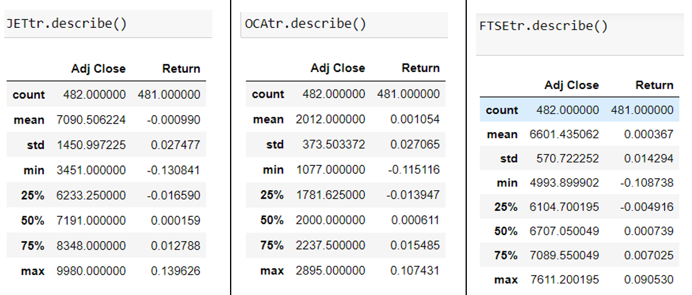

*Figure 3: JET, OCA and FTSE statistics summary*

### Stock returns:

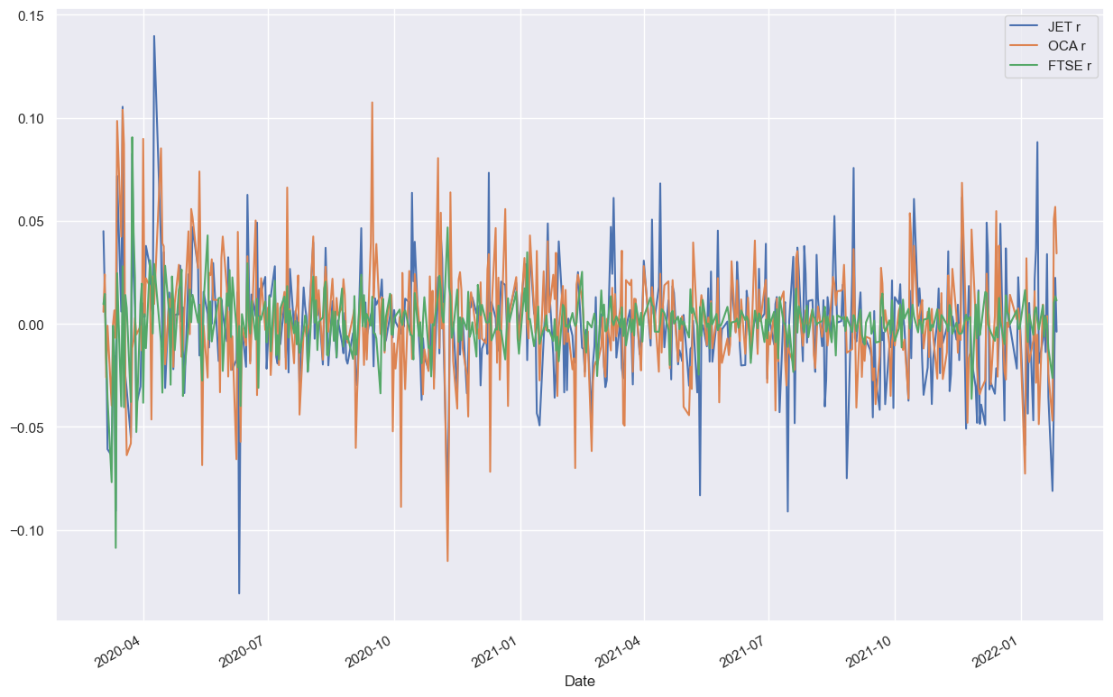

*Figure 4: JET, OCA and FTSE stock return*

As could be seen in *figure 4*, FTSE’s return was much more stable than the companies in the same period of time showing higher volatility of JET and OCA’s stocks.

### JET returns analysis using empirical rules:

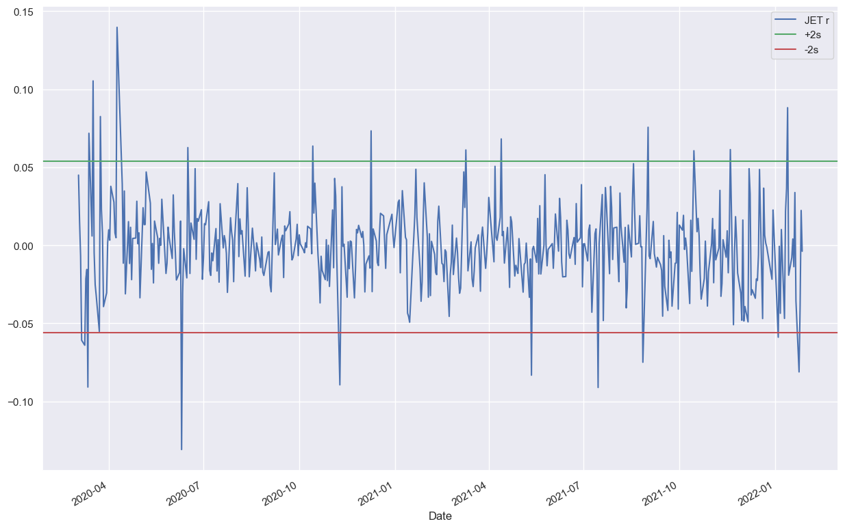

*Figure 5: JET returns analysis*

The empirical rule refers to the observation of data within three standard deviation ranges of the mean so as to make forecast on the distribution of the studied outcomes (Hayes, 2022). To be specific, it is implied that 68% of data will fall within one single standard deviation of the mean (x̅ ± s), the ratios are 95% for two standard deviation range (x̅ ± 2s) and 99.7% for three standard deviation range (x̅ ± 3s), respectively (Frost, n.d.). As shown in *figure 5*, this report applied 2x standard deviation range to examine JET’s return. The result demonstrates that JET stock’s returns are mostly distributed within the range around the mean of zero. However, there are also outliers which reducing the accuracy of predictions and increasing risks of the stock (Freeman, 1995). These outliers show that there are points that the company stock’s return go beyond and below the 2x standard deviation of ± 0.05; its lowest point is -0.130841 on the 10th of June 2020.

### Jet return analysis using boxplot and histogram:

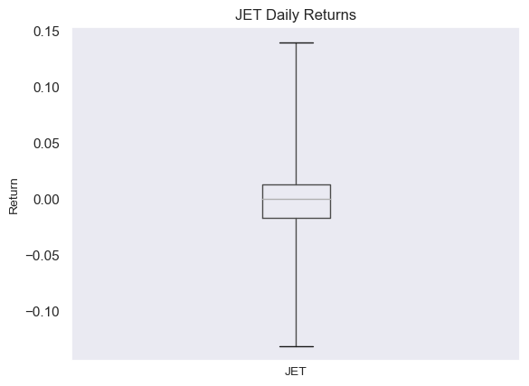

*Figure 6: Boxplot of JET daily returns*

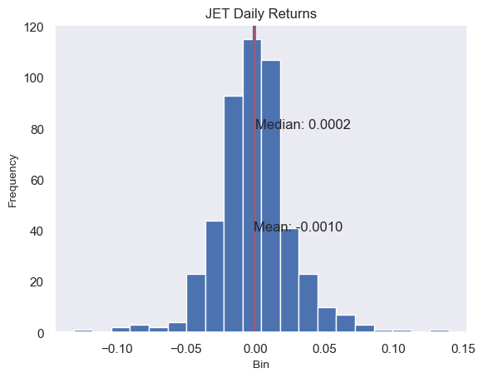

*Figure 7: Histogram of JET daily returns*

The boxplot and histogram in *figure 6* and 7 both show the significant variation of JET’s stock returns. According to Liu (2008), the large size of the box in boxplots represent the high standard deviation proving the instability of JET’s stock as in *figure 6*. However, it could be seen in *figure 7* that the number outliers in negative points are lower than positive ones. This means despite of its volatility, JET’s stock has higher possibility of generating positively favourable returns.

### Comparing returns using boxplot and histogram:

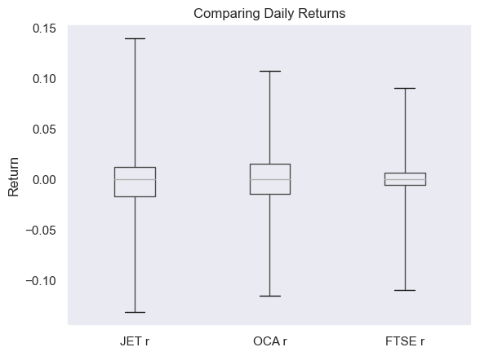

*Figure 8: Boxplot comparing daily returns*

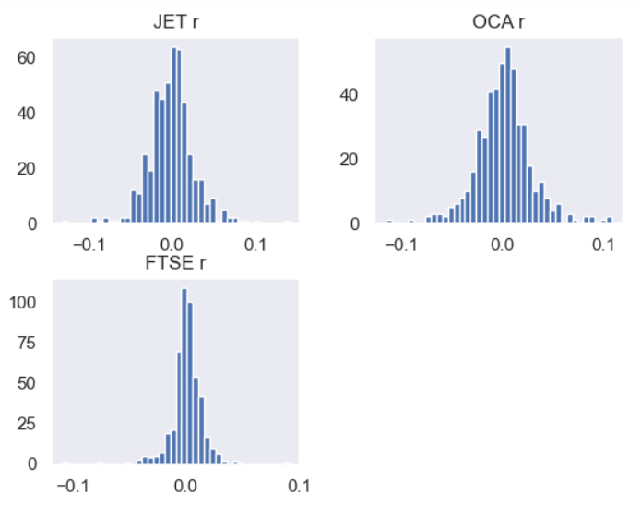

*Figure 9: Histogram comparing daily returns*

The boxplot in *figure 8* indicates that both JET daily returns have the highest variation whilst the figure of FTSE is opposite. Both JET and OCA have higher standard deviation showed by large boxes whilst FTSE’s return standard deviation is much smaller meaning FTSE’s is less volatile than the other two. Besides, *figure 8* and *figure 9* both show that JET’s stock return distribution is negatively skewed whilst that of OCA and FTSE are slightly positively skewed meaning that OCA and FTSE’s stock performance are slightly better than JETs.

## Correlation and Regression Analysis

### Correlation:

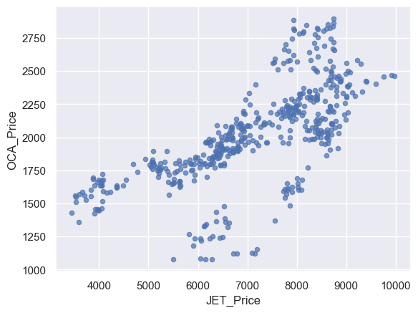

*Figure 10: Correlation between JET and OCA stock prices:*

The scatter plot in *figure 10* demonstrates a relatively high correlation between JET and OCA stock prices meaning the adjustment in one stock price will affect the other.

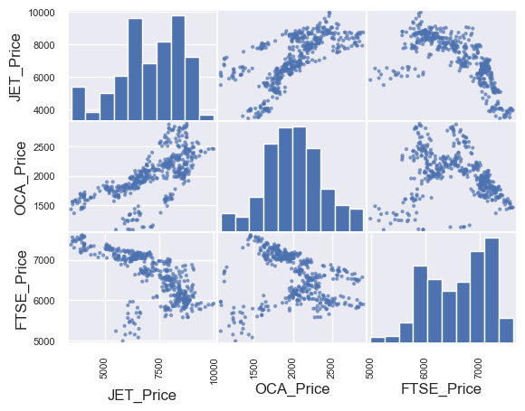

*Figure 11: Correlation between JET, OCA and FTSE stock prices*

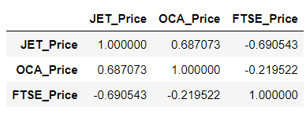

*Figure 12: Result of the correlation between three stocks price*

*Figure 11* and *figure 12* show significant positive relationship between JET and OCA stock price with R-value of 68.7% meanwhile there is a noticeable inverse correlation between FTSE price and JET with negative R-value of -69%. Thus, changes in OCA price have positive impact on JET price while FTSE price negatively influences JET price.

**Correlation between JET, OCA and FTSE stock returns:**

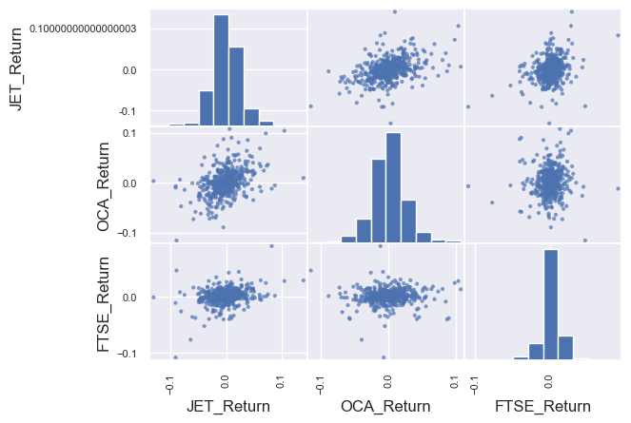

*Figure 13: Correlation between JET, OCA and FTSE stock returns*

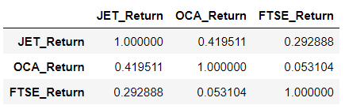

*Figure 14: Results of the correlation between JET, OCA and FTSE stock returns*

The scatter matrix in *figure 13* shows insignificant correlation between all of three stocks’ return. As could be seen in *Figure 14*, all of the R-value are lower than 50% proving that there are weak relationships. Consequently, JET, OCA and FTSE’s stock returns are poorly affected by each other.

### Regression analysis:

For regression analysis, the P-value shows the significant of the correlation between variables, the values lower than 0.05 indicates significant relationship and vice versa. Meanwhile, the R-squared or adjusted R-squared is used to test the strength of that relationship; R-squared value ranging from around 70% and above would imply a strong relationship (Peng et al., 2002).

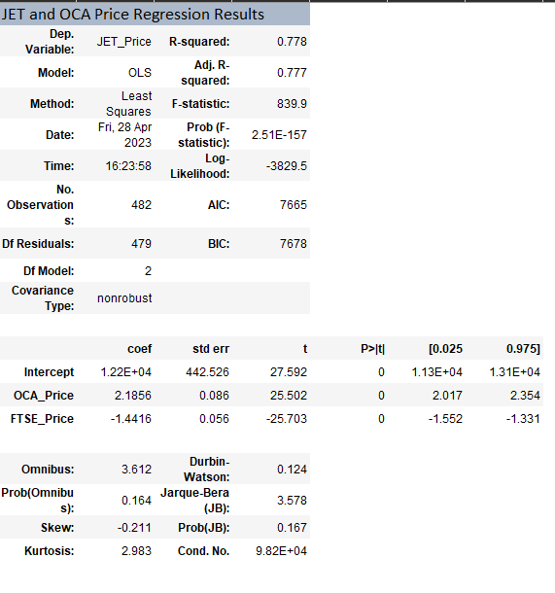

*Figure 15: JET and OCA price regression results*

The results of JET and OCA regression is shown in *figure 15* in which the P-value is 2.51E-157 which is much smaller than 0.05 meaning that there is a significant relationship between JET and its competitor. Since this is a linear regression, R-squared is examined to test the strength of this relationship. In this case, R-squared value is 77.8 %, which is relatively high, showing that JET stock price is strongly affected by the change in OCA’s stock price. This strong relationship is further displayed in *figure 16* below.

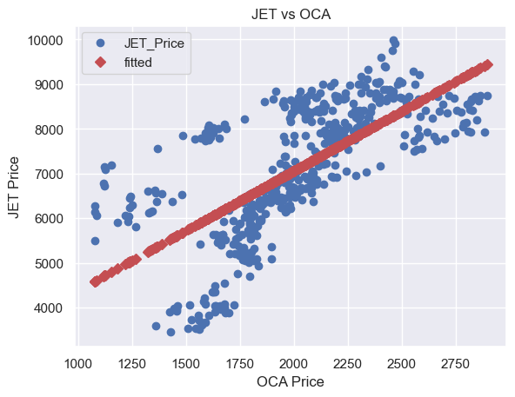

*Figure 16: JET and OCA price regression scatter plot*

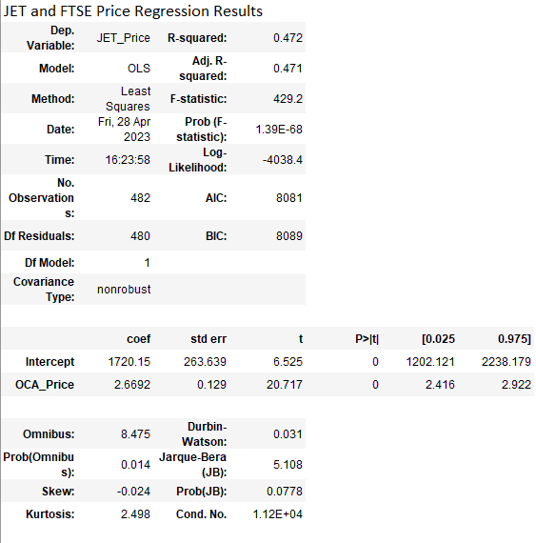

*Figure 17: JET and FTSE price regression results*

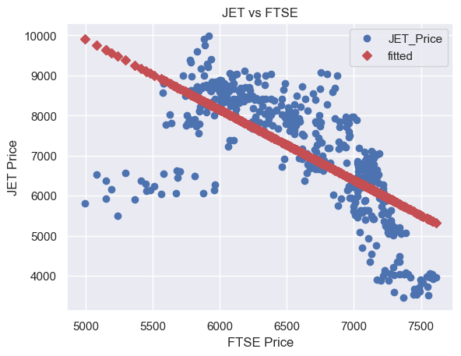

*Figure 18: JET and FTSE price regression scatter plot*

The result in *figure 17* and *figure 18* also indicates a significant correlation between JET and FTSE as the P-value is much lower than 0.05, at 1.39E-68. However, this connection is weak because of the low 47.2% R-squared meaning the adjustment in FTSE stock price only account for less than 50% of the change in JET stock price.

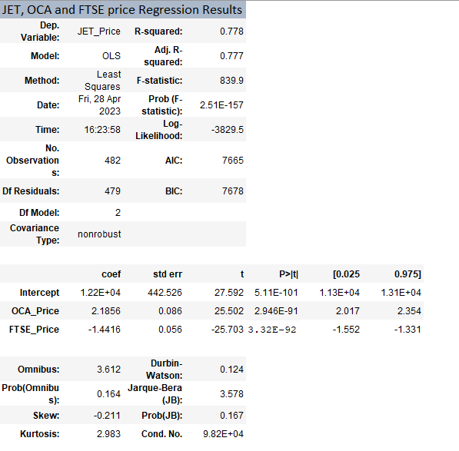

*Figure 19: JET, OCA and FTSE price regression results*

The multiple regression result in *figure 19* shows a significant correlation between JET, OCA and FTSE with the P-value of 2.51E-157, lower than 0.05. Moreover, the high adjusted R-squared value at 77.7% proves that this correlation is strong meaning that JET’s price could be highly influenced by the others two. In comparison, FTSE price’s P-value is 3.32E-92 which is lower than OCA price’s P-value of 2.946E-91 meaning the impact of FTSE stock on JET stock is more significant than OCA stock in this relationship.

## Time Series Analysis

### Moving Average

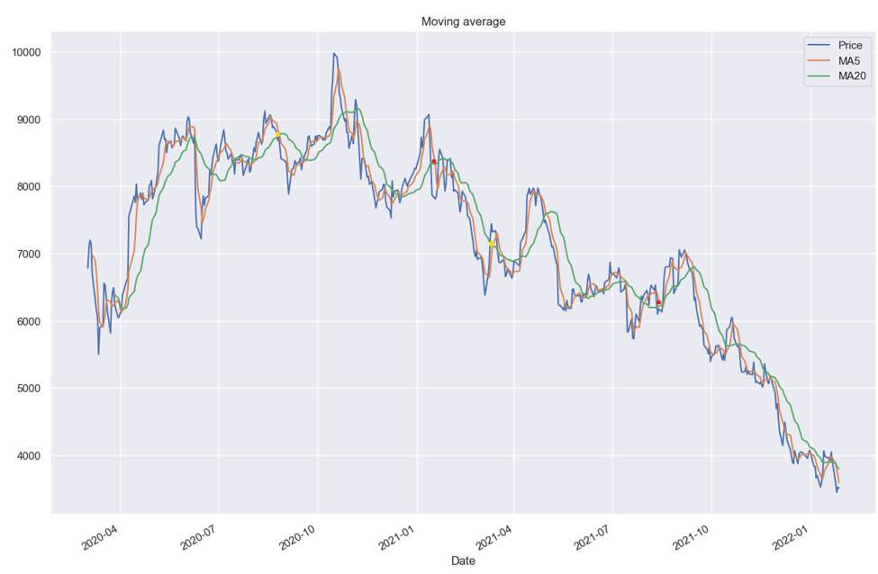

*Figure 20: JET price moving average*

*Figure 20* illustrates the original price of JET with a 5-day short-term moving average and a 20-day long-term moving average. In this case, the buying and selling signals are determined by the Golden cross and the Death cross. In detail, Golden cross appears when the short-term moving average is shifting upward and meet the long-term moving average while it is dropping (The Investopedia Team, 2022). Meanwhile, the pattern for Death cross is completely opposite. The Golden cross represents a good selling signal as it tells an increase in the price of stock whilst investors should buy when Death cross occurs due to the decline in stock price (The Investopedia Team, 2022). In *figure 20*, yellow dots are the example of the points that Golden crosses occur while the red dots represent the Death crosses.

### Forecast:

To compare the results of 5 forecasting methods below, this report will apply the error metrics including Mean Absolute Error (MAE) and Mean Squared Error (MSE). The purpose of these metrics is to focus on the gap between the forecasted value and the real value; thus, the method that has lower MAE and MSE value would has a more accurate forecast (Froehlich et al., 2019). In addition, *appendix 2* includes the calculated error metrics for each method.

**Short-term moving average:**

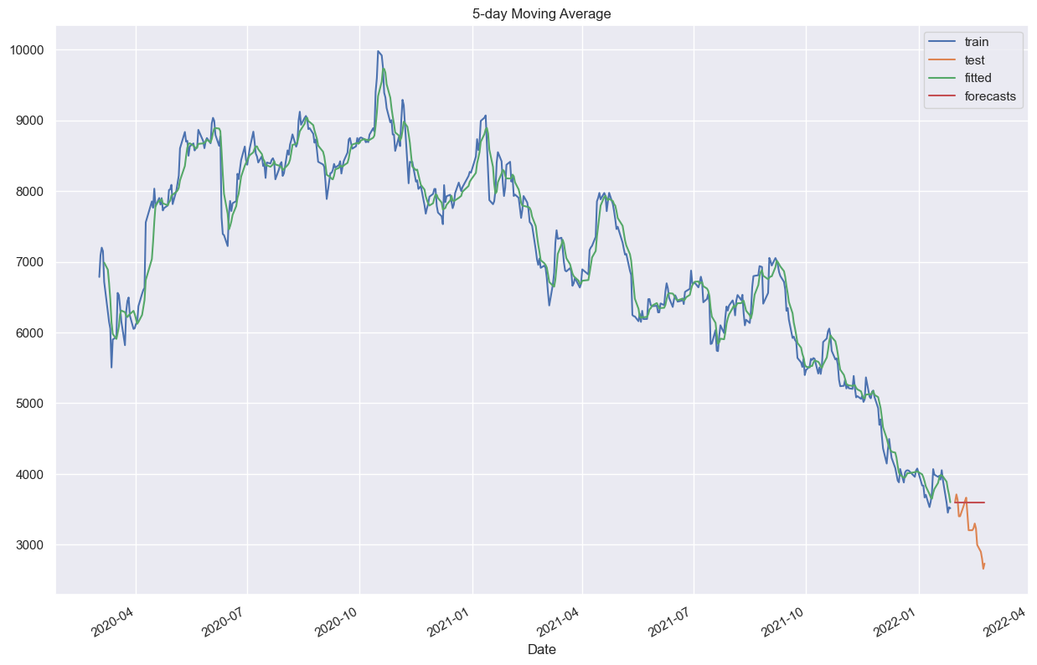

*Figure 21: Forecast using 5-day moving average*

As could be since in *figure 21*, the forecast line is not compatible with the test set prices. Moreover, the MAE and MSE are significantly high which are 346.6579 and 206,777.2763 respectively. Thus, the *short-term moving average* forecast has low accuracy in this case.

**Single Exponential Smoothing**

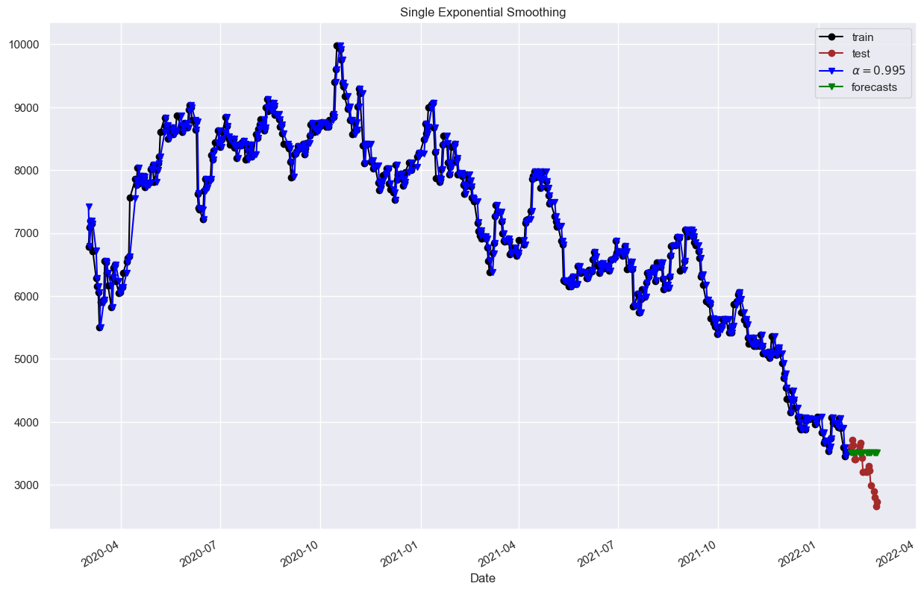

*Figure 22: Forecast using single exponential smoothing*

The test set prices and the forecast line is also not compatible as shown in *figure 22*. However, *single exponential smoothing* error metrics is slightly smaller than short-term moving average’s ones with 310.7873 for MAE and 159,896.6132 for MSE. Therefore, despite having low accuracy, *single exponential smoothing* forecast is slightly better than *short-term moving average.*

**Double Exponential Smoothing**

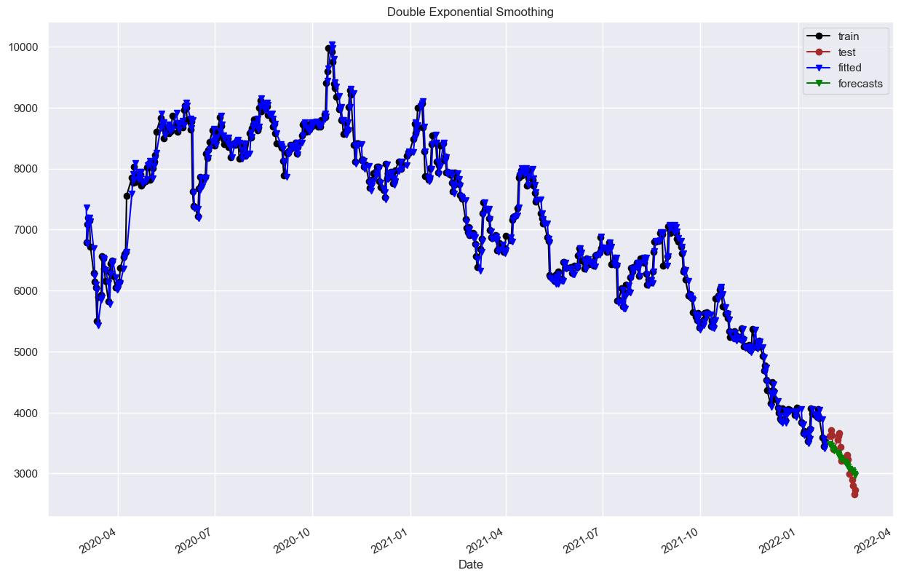

*Figure 23: Forecast using Double Exponential Smoothing*

The forecast line in *figure 23* is almost on top of the test set price. Not only that, the MAE and MSE are 162.8447 and 38,476.8763, respectively which are much smaller than that of *Single Exponential Smoothing*. Thus, *Double Exponential Smoothing* is more accurate than the previous method.

**Holt’s Winters Method (Additive)**

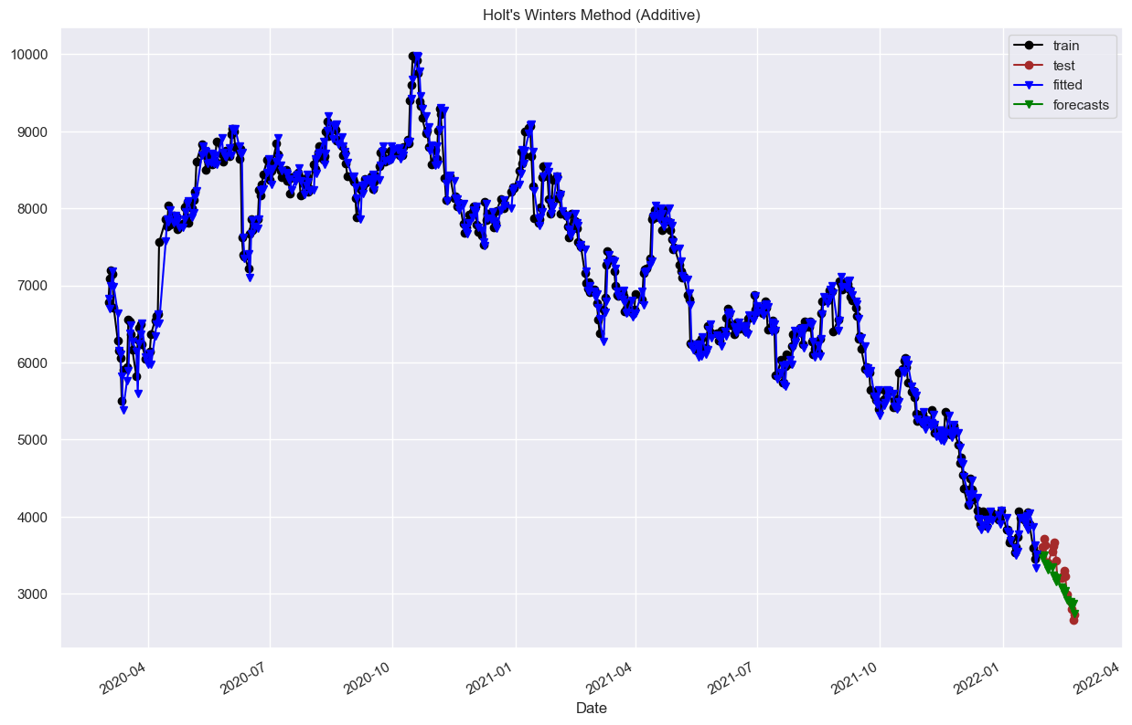

*Figure 24: Forecast using Holt’s Winters Method (Additive)*

The forecast line generated by *Holt’s Winters method* *(Additive)* is visually similar to *Double Exponential Smoothing* which is nearly on top of the test set prices (*figure 24*). However, its error metrics are slightly higher at 164.6826 for MAE and 42,673.5721 for MSE. Thus, *Double Exponential Smoothing* method is slightly more precise than the *Holt’s Winters method* *(Additive).*

**Holt’s – Winters Method (Multiplicative)**

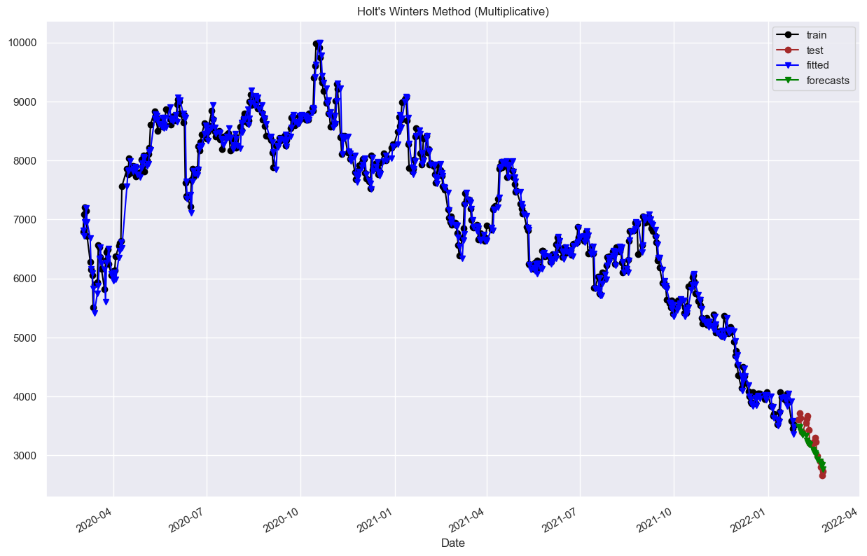

*Figure 25: Forecast using Holt’s Winters Method (Multiplicative)*

The forecast line in *figure 25* is highly compatible with the test set prices. With the MAE of 159.1028 and MSE of 39,330.9363, *Holt’s Winters Method (Multiplicative)* is more accurate than both *Double Exponential Smoothing* method and *Holt’s Winters method* *(Additive)* and it is also the most accurate among all five methods. Thus, the recommended forecasting method for JET prices is the *Holt’s Winters Method (Multiplicative)*.

## Summary:

All in all, the first key finding in this part is that FTSE stock has lower volatility than the companies with stable returns over time. Secondly, despite having wider variation and higher risk than its rival and FTSE, JET stock still has probability to generate higher returns than the others at some points of time. Thus, conservative investors are recommended to invest in the market while the opposite could consider investing in JET.

Furthermore, after performing correlation and regression analysis, it is found that three stocks’ prices have stronger correlation than their returns. Not only that, OCA price has positive impact on JET price whilst the opposite pattern is witnessed in FTSE price. Finally, these impacts that OCA and FTSE’s stock have on JET stock price are all significant; however, the relationship between OCA and JET price is stronger. Therefore, investors are recommended to focus on the price of JET’s rival to make forecast for future investment.

Last but not least, with the *Holt’s Winters Method (Multiplicative)*, JET’s stock value is predicted to decrease. Thus, this could be a buy signal for investors of the company in the future.

# **Fundamental Analysis:**

## Income statements:

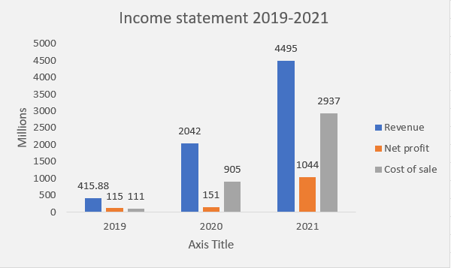

*Figure 26: JET income changes from 2019-2021*

The bar chart in *figure 26* illustrates 3 crucial components in JET’s income statement during the 3 years period from 2019 to 2021. Firstly, it could be observed that there is a massive growth in revenue of JET throughout the years despite of the impacts of the Covid-19 pandemic in that exact period on global businesses. This could be explained by rapid growing demand for the online delivery service during and after the pandemic as lockdown policies at that time restrained people from moving around to buy foods and other necessities (O'Brien, 2020). Although its revenue grew by about 5 times from 2019 to 2020, JET net profit shown an insignificant growth. This phenomenon results from the massive increase in the cost of sales which is 9 time higher than the previous year. However, this is sensible since the company made a commitment to support its restaurants, couriers and customers during that difficult time which directly affects its profit and operational cost (Just Eat Takeaway, 2020). In 2021, due to an explosive increase in the number of customers using JET’s online app, the company’s revenue dramatically increased by a double comparing to the previous year and more than ten times after 2 years. On the other hand, the increase in sales is followed by the increase in all costs including delivery fees and cost of upscaling to meet the market demand (Just Eat Takeaway, 2021). Nevertheless, the massive revenue in 2021 was able to cover the costs generating a stunning net profit of 1044 million pounds.

## Capital structure:

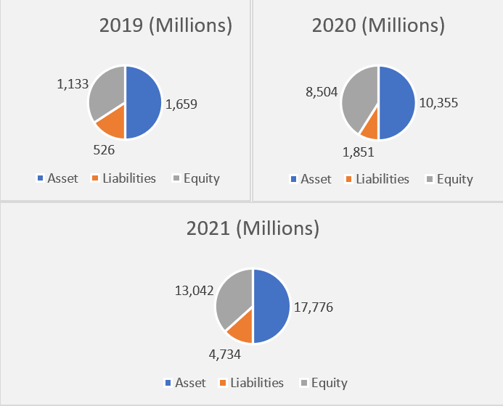

*Figure 27: JET capital structure*

With the massive revenue and profit growth from 2019 to 2021; its unquestionable that JET’s assets have also increased dramatically over time as shown in *figure 27* coming along with the increase in the company’s equity and liabilities. To shareholders, equity is one of the most crucial factors on companies’ balance sheet as its reflect the business value and financial strength (Fernando 2023). Referring to JET capital structure, its 13 times growth in equity showing the company’s strong financial potential to expand further in the future.

## Strategic Analysis:

With the current position in the market, JET is pursuing an ambitious strategic objective to further expand their operation in several territories (Just Eat Takeaway, 2021). To achieve its goal, JET is having clear strategies such as expanding its partnerships with many well-known chains, enhancing the company’s awareness in different markets and many more. Although these are all clear and achievable goals at the moment, they all have one drawback in common which is extremely costly. This fact is represented in *figure 26* as the company’s operational cost is increasing dramatically throughout the years. In the long-term, this could affect JET’s profitability if the company cannot bare the massive costs to pursue their goal. For instance, if Gallagher (2022) prediction about the decline in demand towards delivery services, it would hit directly JET’s profitability as it will not be able to generate enough revenue to cover its costs anymore.

# **Conclusion and Suggestions:**

In conclusion, there is a slight difference in the results of the technical and fundamental analysis sections of the report. On the one hand, the former section concluded that JET's stock return did not perform decently throughout the observed period with high instability. Meanwhile, the results derived from fundamental data indicate that JET has consistently high performance in recent years. Furthermore, JET's price was predicted to fall, contradicting the firm's profitability as shown in its annual reports. As a result, the recommendation for investors is to combine the results of the analyses to make precise investing decisions. While fundamental analysis can help traders investigate potentially profitable stocks, technical analysis can help them decide when and how to invest (Petrusheva and Jordanoski, 2016). In case of JET, the company has impressive financial data in its reports and is absolutely worth investing in. However, to prevent the excessive volatility of the stock, as shown in the technical analysis section, investors should only make long-term investments in the company. Last but not least, the upcoming year 2022 is a suitable opportunity to purchase the stock since it is expected to fall.

# **Reference**

Andrade, C. (2020). Understanding the difference between standard deviation and standard error of the mean, and knowing when to use which. *Indian Journal of Psychological Medicine*, *42*(4), 409-410. <https://doi.org/10.1177/0253717620933419>

Edison Trends. (2021). *In UK Food Delivery Battleground, Just Eat Takes #1 Spot with 45% Market Share.* <https://trends.edison.tech/research/uk-food-delivery.html#:~:text=Between%20February%202020%20and%20February%202021%2C%20the%20size,was%20second%20with%2027%25%2C%20and%20Deliveroo%20had%2026%25>

Fernando, J. (2023). *Equity for Shareholders: How It Works and How to Calculate It*. Investopedia. <https://www.investopedia.com/terms/e/equity.asp#:~:text=Equity%20represents%20the%20shareholders%E2%80%99%20stake%20in%20the%20company%2C,is%20another%20way%20the%20term%20equity%20is%20used>.

Freeman, J. (1995). Outliers in statistical data (3rd edition). *The Journal of the Operational Research Society*, *46*(8), 1034-1035. <https://doi.org/10.1057/jors.1995.142>

Froehlich, S., Grose, D., & Drechsler, R. (2019). One method - all error-metrics: A three-stage approach for error-metric evaluation in approximate computing. Paper presented at the 284-287. <https://doi.org/10.23919/DATE.2019.8715138>

Frost, J. (n.d). *Empirical Rule: Definition & Formula*. Statistics by Jim. <https://statisticsbyjim.com/probability/empirical-rule/>

Gallagher, J.H. (2022). *Increase in home delivery service usage during COVID-19 pandemic unlikely to last*. Rensselaer Polytechnic Institute. <https://phys.org/news/2022-02-home-delivery-usage-covid-pandemic.html>

Hayes, A. (2022). *Empirical Rule: Definition, Formula, Example, How It's Used*. Investopedia.<https://www.investopedia.com/terms/e/empirical-rule.asp#:~:text=The%20empirical%20rule%20is%20used%20often%20in%20statistics,the%20impending%20data%20to%20be%20collected%20and%20analyzed>

Just Eat Takeaway. (2020). *Annual Report 2020*. <https://www.annreports.com/just-eat-takeawaycom/just-eat-takeawaycom-ar-2020.pdf>

Just Eat Takeaway. (2021). *Annual Report 2021*. <https://www.annreports.com/just-eat-takeawaycom/just-eat-takeawaycom-ar-2021.pdf>

Liu, Y. (2008). Box plots: Use and interpretation. *Transfusion (Philadelphia, Pa.), 48*(11), 2279-2280. <https://doi.org/10.1111/j.1537-2995.2008.01925.x>

O'Brien, S.A. (2020). *The pandemic boosted food delivery companies. Soon they may face a reality* *check*. CNN Business. <https://edition.cnn.com/2020/12/06/tech/food-delivery-pandemic-doordash/index.html>

Peng, C. J., Lee, K. L., & Ingersoll, G. M. (2002). An introduction to logistic regression analysis and reporting. *The Journal of Educational Research (Washington, D.C.), 96*(1), 3-14. <https://doi.org/10.1080/00220670209598786>

Petrusheva, N., & Jordanoski, I. (2016). Comparative analysis between the fundamental and technical analysis of stocks. *Journal of Process Management. New Technologies, 4*(2), 26-31. <https://doi.org/10.5937/JPMNT1602026P>

The Investopedia Team. (2022). *Golden Cross vs. Death Cross: What's the Difference?*. Investopedia. <https://www.investopedia.com/ask/answers/121114/what-difference-between-golden-cross-and-death-cross-pattern.asp#:~:text=A%20golden%20cross%20and%20a%20death%20cross%20are,average%20crossing%20over%20a%20major%20long-term%20moving%20average.>

# **Appendix**

## Appendix 1: Deliveroo historical data is limited from the 31st of March 2021



As mentioned in the report, Deliveroo data on the stock market is limited; thus, it could not be used as a competitors for JET.

## Appendix 2: Error metrics calculated for each forecasting method

|  |  |  |  |  |  |
| --- | --- | --- | --- | --- | --- |
| Method | Short-term moving average | Single Exponential Smoothing | Double Exponential Smoothing | Holt’s – Winters Method (Additive) | Holt’s – Winters Method (Multiplicative) |
| MAE | 346.6579 | 310.7873 | 162.8446 | 164.6826 | 159.1028 |
| MSE | 206,777.2763 | 159,896.6132 | 38,476.8763 | 42,673.5721 | 39,330.9363 |